Changes Made to Goldbeter

All results in $μM$ of calcium concentration.

# The Original Goldbeter Model

Keeping the original equations in mind

$$\frac{dZ}{dt} = v_{0} + v_{1}β - v_{2} + v_{3} + k_{f}Y - kZ$$

$$\frac{dY}{dt} = v_{2} - v_{3} - k_{f}Y$$

Where $v_{2}=V_{M2}\frac{Z^{n}}{K_{2}^{n}+Z^{n}}$ and $v_{3}=V_{M3} \frac{Y^{m}}{K_{R}^{m}+Y^{m}}\frac{Z^{p}}{K_{A}^{p}+Z^{p}}$

The relationship between beta and position is 1:1.

Results:

Calcium concentration in the Cytosol

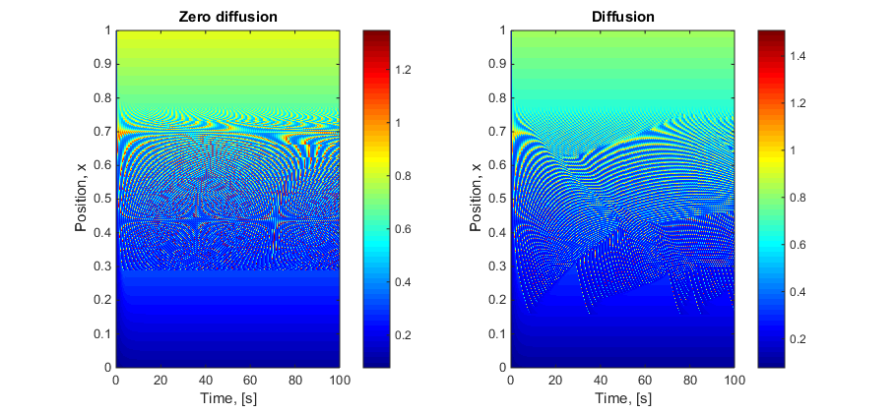

Steady state region to oscillatory to steady state as beta increases.

Calcium concentration in the store

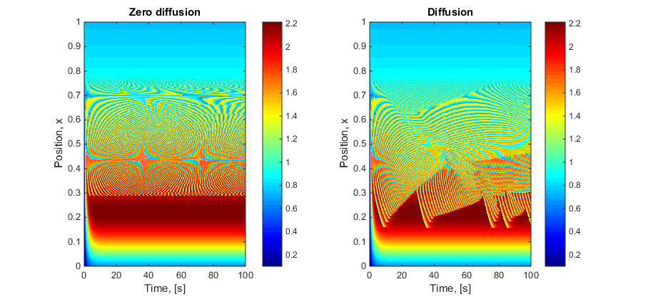

# Removal of v1 from rate of change of intracellular store

Subtract v1β from the Y equation to effectively combine the stores.

$$\frac{dZ}{dt} = v_{0} + v_{1}β - v_{2} + v_{3} + k_{f}Y - kZ$$

$$\frac{dY}{dt} = v_{2} - v_{3} - k_{f}Y - v_{1}β$$

The relationship between beta and position is 1:1.

Results:

Calcium concentration in the Cytosol

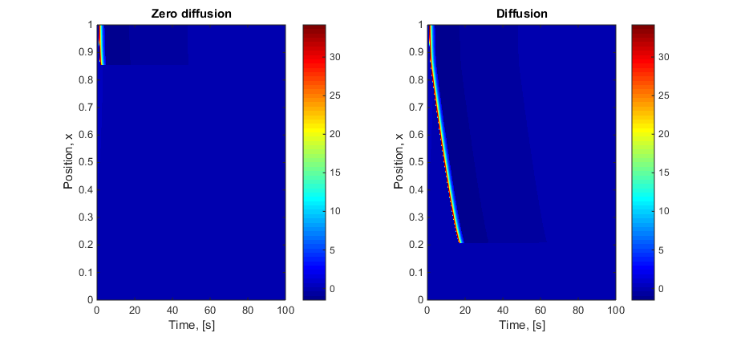

Calcium concentration in the store

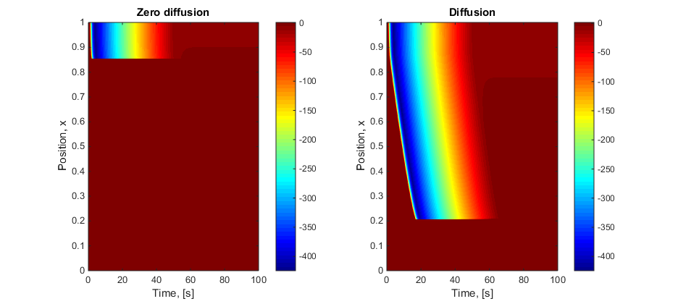

Conclusion:

It stays at steady state for the rest of time after the first wave. This does not appear to work and the reason I believe is that the second store is expected to be replenished from external sources at a rate of v1β.

# Addition of volume ratio factor

Considering that the store is a significantly smaller volume than that of the cytosol it should be multiplied by a volume ratio. This format was taken from Hannah Farr and Tim David’s 2011 paper.

$$\frac{dZ}{dt} = v_{0} + v_{1}β - v_{2} + v_{3} + k_{f}Y - kZ$$

$$\frac{dY}{dt} =\frac{1}{VR_{ERcyt}}{(v}_{2} - v_{3} - k_{f}Y )$$

where VRERcyt is equal to 0.185. Again the relationship between beta and position is 1:1.

Results:

Calcium concentration in the Cytosol

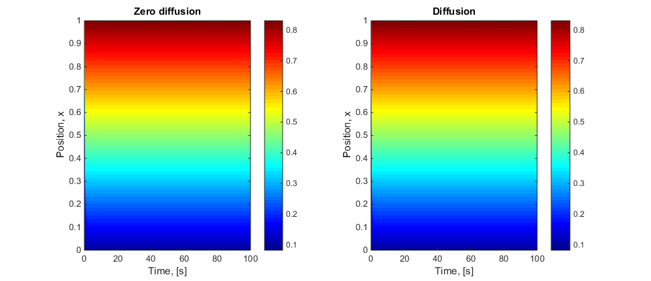

Calcium concentration in the store

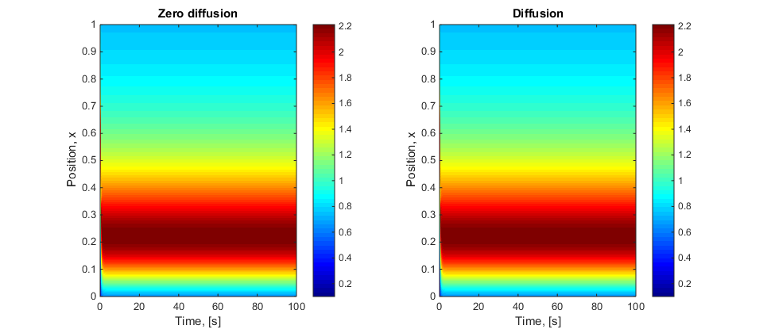

Conclusion:

This does not work, it is unclear why just yet.

# Addition of Buffering term

Now considering buffering of the calcium in the store. This format was taken from Hannah Farr and Tim David’s 2011 paper.

$$\frac{dZ}{dt} = B_{cyt}(v_{0} + v_{1}β - v_{2} + v_{3} + k_{f}Y - kZ)$$

$$\frac{dY}{dt} =B_{cyt}{(v}_{2} - v_{3} - k_{f}Y )$$

where $B_{cyt}$ is equal to 0.0244. Again the relationship between beta and position is 1:1.

Results:

Calcium concentration in the Cytosol:

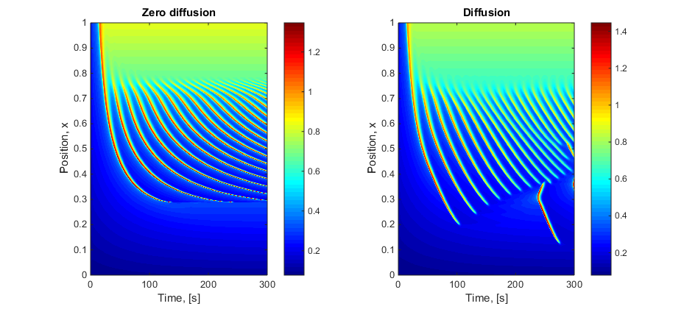

Calcium concentration in the store:

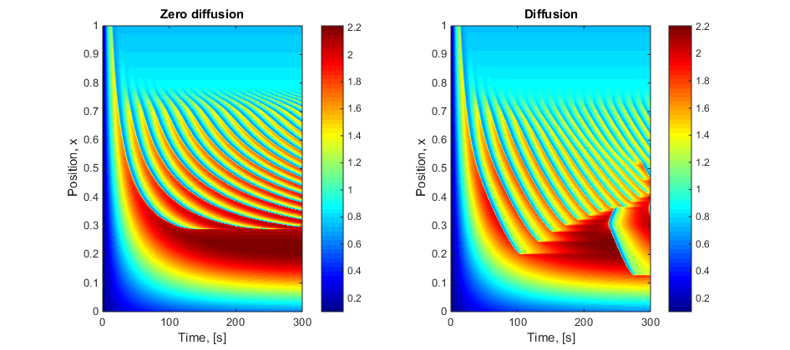

Conclusion:

This does work. It appears to slow down the oscillations taking 300 seconds to look the same as the original Goldbeter model.

# Consider both Volume ratio and Buffering term

Now considering both the Volume ratio and buffering of the calcium in the store. This is because that is how Hannah Farr and Tim David’s 2011 paper has done it.

where is equal to 0.0244 and VRERcyt is equal to 0.185. Again the relationship between beta and position is 1:1.

Results:

Calcium concentration in the Cytosol:

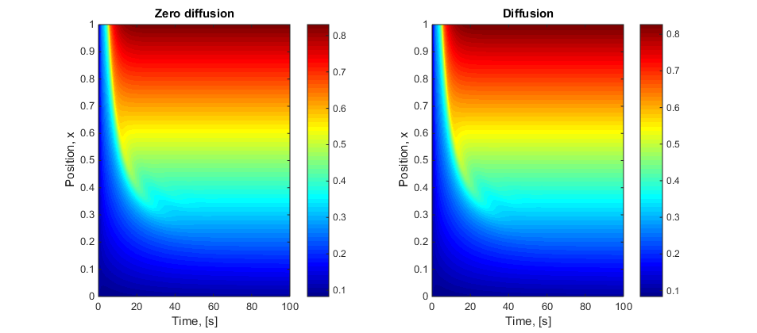

Calcium concentration in the store:

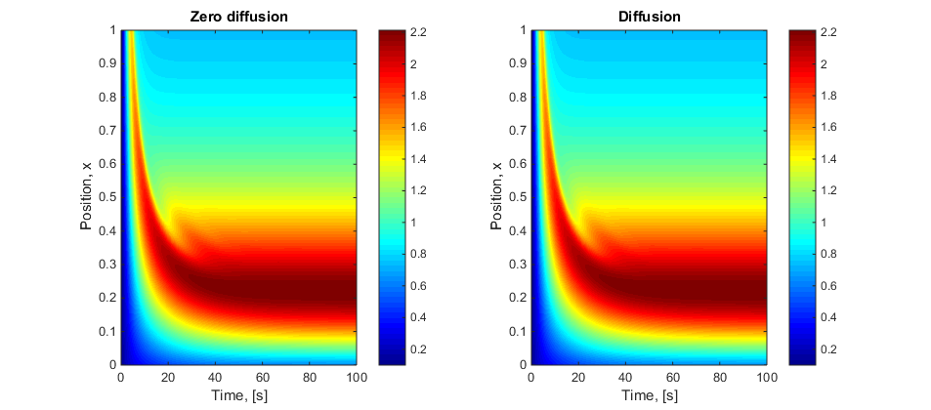

Conclusion:

This does not work, it is unclear why just yet.

# Consider all three Volume ratio and Buffering term

Now considering both the Volume ratio and buffering of the calcium in the store. This is because that is how Hannah Farr and Tim David’s 2011 paper has done it.

where is equal to 0.0244 and VRERcyt is equal to 0.185. Again the relationship between beta and position is 1:1.

Results:

Calcium concentration in the Cytosol

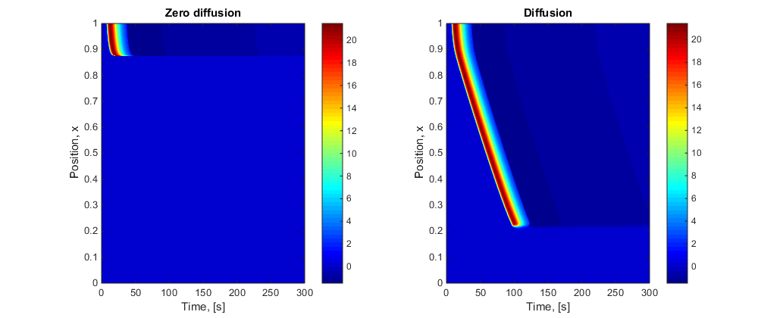

Calcium concentration in the store

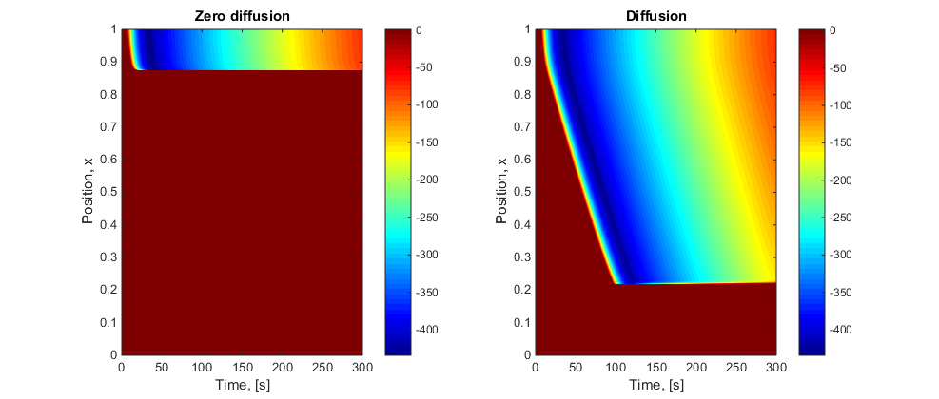

Conclusion:

This does not work, it is unclear why just yet.

# Conclusions

|  |  |  |
| --- | --- | --- |
| Number | Change | Result |
| 1 | Removal of v1 from rate of change of intracellular store | Only 1 oscillation ever, Negative Y |
| 2 | Addition of Volume ratio factor | No oscillation |
| 3 | Addition of Buffering term | Slowed everything down in time |
| 4 | Combination 2 and 3 | No oscillations |
| 5 | Combination of 1, 2 and 3 | Only 1 oscillation ever, Negative Y |

I believe that the constants v1 to v3, k and kf include these terms already factored in.